PROJECT REPORT

MIZA M
INFOSYS SPRINGBOARD INTERN

Table of Contents

- Abstract
- Introduction
- Problem Statement
- Project Objectives
- Literature Motivation and Background
- Proposed System
- Methodology
- System Architecture and Workflow
- Implementation Details
- Performance Evaluation
- Results and Discussion
- Visualization and Dashboard
- Conclusion
- Future Work

AI-Driven Archaeological Site Analysis System

1. Abstract
Archaeological site identification and preservation traditionally rely on manual field surveys and expert visual interpretation of aerial imagery. These approaches are time-consuming, labor-intensive, and often limited by terrain accessibility and environmental conditions. With the growing availability of high-resolution satellite and drone imagery, there is a strong need for intelligent automated systems that can assist archaeologists in analyzing large-scale spatial data efficiently.
This project presents an AI-Driven Archaeological Site Analysis System that integrates Artificial Intelligence (AI), Machine Learning (ML), and Computer Vision (CV) techniques to automate archaeological image analysis. The system performs semantic segmentation using a U-Net architecture to classify land-cover features, object detection using YOLO to identify archaeological structures, and terrain erosion prediction using machine learning models based on derived terrain features. All components are integrated into a single interactive application for visualization and analysis. The proposed system demonstrates effective performance and provides a scalable, data-driven solution to support archaeological research and site preservation.

2. Introduction
Archaeology plays a vital role in understanding human history and cultural heritage. Traditional archaeological surveys depend heavily on manual exploration, field excavation, and visual analysis of maps and images. These methods are not only time-consuming but also constrained by geographical challenges and limited resources.
Recent advancements in Artificial Intelligence and Computer Vision have enabled automated interpretation of visual data across various domains. In archaeology, AI-based analysis of aerial and satellite imagery can significantly enhance the detection of potential sites and assist in environmental risk assessment. By leveraging deep learning and machine learning techniques, large volumes of imagery can be processed efficiently with improved accuracy.
This project aims to apply these technologies to develop an intelligent system capable of analyzing archaeological landscapes through segmentation, detection, and terrain assessment, thereby supporting faster and more informed decision-making.

3. Problem Statement
Manual archaeological site identification from aerial imagery is inefficient, subjective, and prone to human error. The lack of automated tools makes it difficult to analyze large-scale imagery, detect subtle archaeological features, and assess environmental risks such as erosion. There is a need for a unified system that can automatically analyze images, detect structures, classify land-cover features, and evaluate terrain stability.

4. Project Objectives
The main objectives of this project are:
- To develop an AI-based system for automated archaeological site analysis
- To perform semantic segmentation of aerial images to identify vegetation, ruins, and background areas
- To implement object detection for identifying archaeological structures using YOLO
- To predict terrain erosion risk using machine learning models
- To integrate segmentation, detection, and erosion prediction into a single interactive application
- To provide visual outputs that enhance interpretability for archaeological research

5. Literature Motivation and Background
Recent studies have demonstrated the effectiveness of deep learning models such as U-Net for semantic segmentation and YOLO for real-time object detection in remote sensing applications. Machine learning models like Random Forest and XGBoost have also been widely used for environmental risk assessment and terrain analysis.
Inspired by these advancements, this project combines multiple AI techniques into a unified framework specifically tailored for archaeological site analysis, bridging the gap between image-based interpretation and environmental risk evaluation.

6. Proposed System
The proposed system consists of three core analytical modules:
- Semantic Segmentation Module – Identifies land-cover features at the pixel level
- Object Detection Module – Detects archaeological structures using bounding boxes
- Terrain Erosion Prediction Module – Classifies terrain as stable or erosion-prone
These modules are integrated into a single pipeline and deployed through an interactive dashboard to provide real-time analysis and visualization.

7. Methodology
The methodology followed in this project includes:
- Dataset preparation and preprocessing
- Semantic segmentation using a U-Net model
- Object detection using a pretrained YOLO model
- Terrain feature extraction using image processing techniques
- Erosion risk prediction using machine learning models
- Integration and visualization through a web-based interface

8. System Architecture and Workflow
The system workflow begins with input image acquisition, followed by preprocessing. The image is then passed through the U-Net model for segmentation and the YOLO model for object detection. Simultaneously, terrain features such as vegetation ratio and slope score are extracted and used as inputs for the erosion prediction model. Finally, all outputs are visualized through an interactive dashboard.

9. Implementation Details
- Semantic Segmentation: Implemented using a U-Net architecture with a ResNet-based encoder
- Object Detection: Implemented using YOLO for efficient and accurate structure detection
- Terrain Analysis: Features such as vegetation ratio and slope score derived using OpenCV
- Erosion Prediction: Machine learning model trained to classify erosion risk
- Deployment: Integrated using Streamlit for interactive visualization

10. Performance Evaluation
The system was evaluated based on segmentation quality, detection accuracy, and erosion prediction reliability. The segmentation model effectively classified vegetation and ruins, while the YOLO model successfully localized archaeological structures. The erosion prediction module demonstrated strong predictive performance based on extracted terrain features.

11. Results and Discussion
The results show that the integrated system can accurately analyze aerial imagery and provide meaningful insights for archaeological site assessment. The combination of pixel-level segmentation, object-level detection, and terrain-based prediction offers a comprehensive understanding of archaeological landscapes.

12. Visualization and Dashboard
An interactive Streamlit-based dashboard was developed to display:
- Original input image
- Segmentation output
- Object detection results
- Terrain erosion metrics
This visualization enhances usability and allows users to interpret results intuitively.

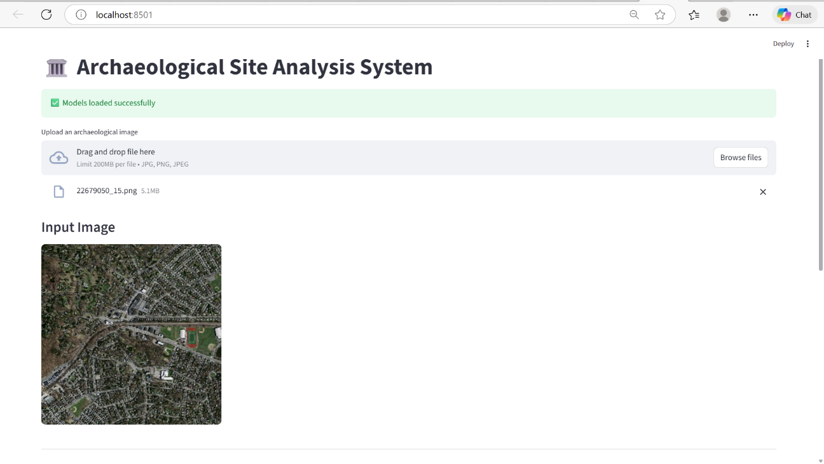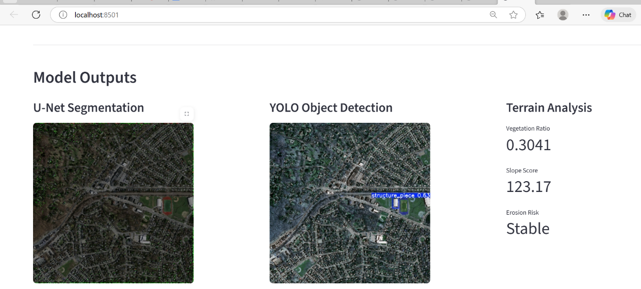

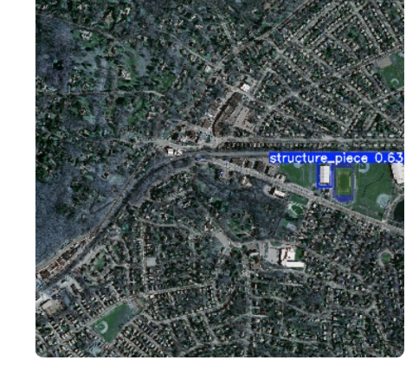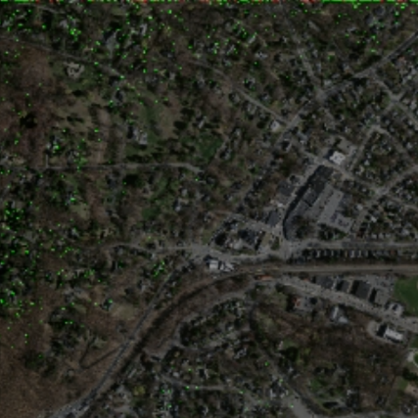

13. Conclusion
This project successfully demonstrates the application of Artificial Intelligence, Machine Learning, and Computer Vision in archaeological site analysis. By automating segmentation, detection, and terrain erosion prediction, the system reduces manual effort and improves analytical efficiency. The integrated framework provides a scalable and practical solution for archaeological research and preservation planning.

14. Future Work
Future enhancements may include:
- Integration of multispectral and LiDAR data
- Training with larger and more diverse datasets
- GIS-based spatial visualization
- Cloud deployment for large-scale analysis
- Temporal analysis for monitoring site changes over time

